**NODE JS backend production level initialisation**

1. **npm init** : *initialising the project*
2. **npm install** : *cmd to install the required packages like( nodemon, cors, body-*parser, dotenv etc)
3. **npm i husky lint-staged-D***: setup the husky which is basically error check before commiting.*
4. **npm husky init :** *initialise the husky( basically create the folder name husky inside corresponding folder there is precommit file just need to npm {name of the file})*

**TypeScript Integration ( if need ) . required in large scale production.**

1. **npm i typescript –D :** *installing typescript.*
2. **npx tsc --init:** *tsconfig.json file will created. This are basically the setting which required for the project.*

*My Personal requirement for initialisation in tsconfig****.****json*

{

  "target": "es2016",

  "module": "commonjs",

  "rootDir": "./src",

  "outDir": "./dist",

  "removeComments": true,

  "esModuleInterop": true,

  "forceConsistentCasingInFileNames": true,

  "strict": true,

  "noImplicitAny": true,

  "strictNullChecks": true,

  "strictFunctionTypes": true,

  "strictPropertyInitialization": true,

  "alwaysStrict": true,

  "noUnusedLocals": true,

  "noUnusedParameters": true,

  "noImplicitReturns": true,

  "skipLibCheck": true

}

1. **npm i -D @types/node:** *it provides type definitions for Node.js's built-in APIs*
2. **npm i ts-node -D :** *ts node helps to run typescript without compiling to javascript first*
3. **add script in package.json**

 "scripts": {

  "dist": "npx tsc",

    "dev": "node src/index.ts",

  "start": "node dist/index.js",

  "prepare": "husky"

  },

1. **npx tsc** *: this will create dist folder where index.js will be created*

**Folder structure**

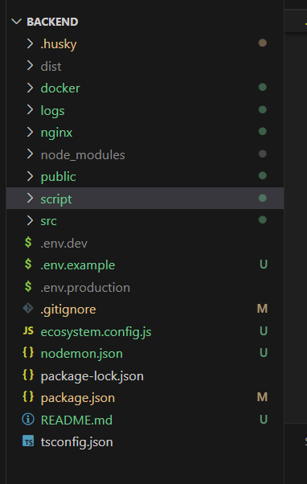

**SRC**

